**Supplementary Information**

**Impact of limited address data on health effect analysis of long-term air pollution in a simulation study**

Yoon-Bae Jun, Insang Song, Sun-Young Kim

**Details of simulation procedure**…………………………………………………2

**List of Figures**

**Figure S1.** Summary flow charts ………………………..……………………………….…...8

**Figure S2.** Maps of the true simulated annual-average PM10 concentrations………………...9

**Figure S3.** Box-plots of true and predicted annual-average PM10 concentrations…………..10

**Figure S4.** Scatter plots of true and predicted annual-average PM10 concentrations………11

**Figure S5.** Bar plots of bias of health effect estimates……………………………………...12

**Figure S6.** Bar plots of root mean square error, average standard error, and coverage probability of health effect estimates…………………………………………..…………...14

**Figure S7.** Bar plots of true-positive rate of health effect estimates………………………15

**Figure S8.** Maps of South Korea and Seoul, the Capital of South Korea………………….16

**List of Tables**

**Table S1.** Mean and standard deviation of true and predicted PM10………………………...17

**Table S2.** Correlation and regression coefficients of true and predicted PM10 …...19

**Table S3.** Properties of health effect estimates of true and predicted PM10 (ES1-ES4) …...22

**Table S4.** Properties of health effect estimates of true and predicted PM10 (ES5-ES8)........24

**Details of simulation procedure**

Method Overview

Our simulation procedure consists of three steps. First, we performed exploratory data analyses and obtained parameters for the underlying distributions of PM10 and LBW. Using the underlying distributions and parameters, we generated annual-average PM10 concentrations at all locations including mothers’ homes and regulatory monitoring sites according to eight different environmental scenarios (ES1-ES8) and generated LBW status of mothers. Second, we constructed home addresses of mothers, and estimated individual-level PM10 exposures at mothers’ homes using “true” simulated (observed) concentrations at monitoring sites and nine prediction methods. Finally, we conducted health analysis of LBW for individual-level PM10 concentrations and compared the performance of health effect estimates across different scenarios of data availability, exposure environment, and prediction method.

Data Analysis and Parameter Acquisition

We obtained parameters to be applied to our simulation from the exploratory analysis of air quality regulatory monitoring data for PM10, geographic variables, and birth certificate data in Seoul, South Korea, during 2010. Hourly PM10 measurement data in the regulatory monitoring network were obtained from the National Institute of Environmental Research. The air quality regulatory monitoring network in Seoul includes 25 urban-background and 12 urban-roadside sites in 2010. Urban-background sites are located in heavily populated residential areas with the aim of assessing the population level of exposure; one monitoring site is deployed in each of the 25 districts in Seoul28. In contrast, urban-roadside sites are located next to large and busy major roads for monitoring air pollution affected by traffic emissions. Using hourly measurements, we computed daily averages at each site for the days when at least 75% of hourly measurements are available. Then, the annual average concentrations were computed at each site where there is at least one daily measurement in each of the 10 months and in any 45 consecutive days29.

Using annual average concentrations of PM10, we fitted variogram models and estimated mean and variance parameters. Three variance parameters include range, partial sill, and nugget that indicate the distance in which spatial correlation exists, spatial variability, and non-spatial variability, respectively30. Five mean parameters were regression coefficients of five geographic variables that were most related to fine particulate matter less than or equal to 2.5 micrometer per diameter (PM2.5) in our previous study for Seoul31. The data sources of geographic variables and computation procedure in Geographic Information System were described elsewhere32. These variables include the length of major roads in a 100 m circular buffer, the proportion of water surface land use in 500 m, the number of construction companies in 1,000 m, the distance to the nearest bus stop, and the number of employees in construction industries in 100 m.

We obtained birth certificate data from the Statistical Geographic Information Service operated by the Statistics Korea. Term LBW babies were defined as singleton live birth between 37 to 41 weeks with less than 2.5 kilograms27. We computed the proportion of LBW cases to the total births (0.016) and used in the simulation as the true LBW proportion. The underlying effect estimate of PM10 on LBW (0.003) was obtained from the previous study of the association between PM10 and LBW in 549,270 non-employed mothers residing in Seoul, for 2002-201227. To focus on the spatial variation, we restricted our study period to a single year in 2010 and selected 46,007 mothers who had births in 2010.

Residential Address Assignment

Because mothers’ residential addresses in birth certificate data are available at the district level, we generated the locations of mothers’ homes based on the spatial distribution of the number of births. Seoul, the Capital of South Korea, is composed of 25 districts (median area and average population in 2010: 21.59 km2 and 412,520) and 422 neighbourhoods (8.69 km2 and 24,323). There are 16,230 census tracts (0.02 km2 and 821) as the smallest census territorial unit nested within neighbourhoods. We treated census tract centroids as a small unit of mothers’ potential home addresses and randomly sampled the centroids for the mothers in each district with the weight of the numbers of live births across neighbourhoods of each district. Census tract centroids are considered socio-demographically homogeneous within an area and different across areas. Consequently, the geographic constraints on the census tract centroids of residential addresses can reflect the real situation much better than naïve random address assignment. We treated these locations fixed over the simulation.

Exposure Generation

|  |  |  |
| --- | --- | --- |
|  |  | (1) |

We generated true annual average PM10 concentrations, as true exposures to PM10, at all locations including 46,007 mothers’ homes, 37 air quality regulatory monitoring sites, and the centroids of 25 district governmental offices, 422 neighbourhood community centers, 16,230 census tract centroids, and 610 centroids on the 1-km grid in Seoul. As shown in the equation (1), we assumed that the true exposure to PM10 at a location s, , follows Gaussian random field, and is partitioned into three components of global mean,, spatial error,, and non-spatial error,. is a linear function of predictors, , characterized by mean parameters, . These predictors include five geographic variables that were most associated with particulate matter concentrations in our previous study29. is a spatial random process characterized by partial sill, , and range, , that represent spatial variability and the distance in which spatial correlation exists, respectively. is a non-spatial random process indicating measurement error and characterized by nugget, , representing non-spatial variability. Consequently, the total variability of the true PM10 annual-average concentrations,, can be partitioned into global trend variability, , partial sill, , and nugget, .

To represent possibly different spatial structures of true PM10 annual average concentrations, we constructed eight environmental scenarios (ES1-ES8) based on varying contributions of the three components of PM10 to total variability (Table 1, Figure S1). ES1 to ES4 has a constant mean (i.e. ) and different variance parameters of range, partial sill, and nugget which represent different contribution to spatial and non-spatial variability. From ES1 to ES4, the contribution of spatial variability decreases while the contribution of non-spatial variability increases. The other four scenarios (ES5-ES8) include mean structures characterized by five geographic variables (i.e. ) in addition to different combination of variance parameters. Whereas ES5 and ES6 have intermediate contribution of mean structure, ES7 and ES8 have dominant contribution. ES5 and ES7 contain more spatial variability than non-spatial variability, while ES6 and ES8 comprise more non-spatial variability than spatial variability. ES8 was constructed by using the parameters that best represent the data, indicating the most similar environment to Seoul.

Outcome Generation

LBW status of mothers were generated based on the proportion of LBW cases obtained by our exploratory data analysis (see the Data Analysis and Parameter Acquisition section), simulated true PM10 concentrations (see the Exposure Generation section), and the effect estimate of LBW for PM10 obtained by our previous study28. We assumed that LBW probability of a mother, p, follows an inverse logit function of true baseline LBW rate () and the true effect estimate of LBW () for individual PM10 concentration (X), as shown in the equation 2.

|  |  |  |
| --- | --- | --- |
|  | . | (2) |

Then, given LBW probability of each mother, p, we randomly generated LBW status from Bernoulli distribution.

Health Effect Estimation

Using true or predicted PM10 and true LBW status of mothers, we estimated health effects of LBW, and computed properties of health effect estimates () over 1,000 simulations to evaluate accuracy of effect estimates depending on different scenarios for data availability, exposure prediction methods, and pollution environments. These properties include bias (), root mean square error (RMSE) (), average of standard error (ASE) (), and coverage probability (CP) (), where if the condition is true, and otherwise. RMSE and ASE indicate the uncertainty of effect estimates on average, while CP presents the probability of including the true effect estimate within estimated 95% confidence intervals. In addition, to explore the impact of data availability and prediction approaches on statistical power to detect the true association, we computed the relevant true positive rate, which is the ratio of the number of simulations that provide significantly positive effect estimates (p-value < 0.05) to the number of significant simulations under fully known individual PM10 measurements.

Figure S1 Summary flow charts of our simulation study that consists of three sequential categories: (1) Data analysis and Parameter Acquisition; (12) Simulate environmental scenarios; (23) Data availability conditions and exposure assessment; and (34) Health effect estimation. Details are provided throughout our METHOD section.

**Figure S2.** Maps of true simulated annual-average PM10 concentrations by eight environmental scenarios (ESs) in Seoul, Korea

|  |  |  |  |
| --- | --- | --- | --- |
| **ES1** | **ES2** | **ES3** | **ES4** |
|  |  |  |  |
| **ES5** | **ES6** | **ES7** | **ES8** |
|  |  |  |  |

**Figure S3.** Scatter plots of true (x-axis) and predicted (y-axis) annual-average PM10 concentrations at home addresses of 46,007 mothers in the 1st simulation (blue and red lines for regression 45 degree lines, respectively)

|  |  |  |  |  |  |  |  |  |  |  |  |  |  |  |  |  |
| --- | --- | --- | --- | --- | --- | --- | --- | --- | --- | --- | --- | --- | --- | --- | --- | --- |
|  | ES1 | | ES2 | | ES3 | | ES4 | | ES5 | | ES6 | | ES7 | | ES8 | |
| NM | |  | |  | |  | |  | |  | |  | |  | |  |
| IDWA | |  | |  | |  | |  | |  | |  | |  | |  |
| LUR | |  | |  | |  | |  | |  | |  | |  | |  |
| UK | |  | |  | |  | |  | |  | |  | |  | |  |
| AA | |  | |  | |  | |  | |  | |  | |  | |  |
| UKD | |  | |  | |  | |  | |  | |  | |  | |  |
| UKNA | |  | |  | |  | |  | |  | |  | |  | |  |
| UKCA | |  | |  | |  | |  | |  | |  | |  | |  |
| UKGA | |  | |  | |  | |  | |  | |  | |  | |  |

**Figure S4.** Bar plots of bias (multiplied by 100) for effect estimates of low birth weight on true and predicted PM10 concentrations across true and nine exposure prediction methods (TE: true exposure, NM: nearest monitor, IDWA: inverse distance weight average, LUR: Land-use regression, AA: area average, UK: universal kriging, UKD: UK prediction at governmental offices; UKNA: district average based on UK predictions at 422 neighbourhood community centers; UKCA: district average of UK predictions at 16,230 census tract centroids; UKGA: district average of UK predictions at 610 1-km grid coordinates) by eight environmental scenarios (blue bars for true exposure; yellow and orange bars for predicted exposure with complete and incomplete addresses, respectively)

|  |  |
| --- | --- |
|  |  |
|  |  |
|  |  |
|  |  |

**Figure S5.** Bar plots of root mean square error (filled bar), average standard error (empty bar), and coverage probability (grey point) for effect estimates of true and predicted PM10 concentrations on low birth weight across ten exposure assessment methods by eight environmental scenarios.

|  |  |
| --- | --- |
|  |  |
|  |  |
|  |  |
|  |  |

**Figure S6.** True-positive rate for effect estimates of true and predicted PM10 concentrations on low birth weight across 10 exposure assessment methods by eight environmental scenarios across two data availability conditions (yellow, and orange bars for complete address, and for incomplete address, respectively) by eight environmental scenarios

|  |  |
| --- | --- |
|  |  |
|  |  |
|  |  |
|  |  |

**Figure S7.** Top panel represents maps of South Korea and Seoul, the Capital of South Korea. (a) Bottom panel shows maps of 25 urban-background regular monitoring sites (red) and 25 districts in Seoul (b), and neighborhood community centers (light blue) and census tracts centroids (light purple) (c) and 1-km grid coordinates (green) (d) in a red-lined district in (b)

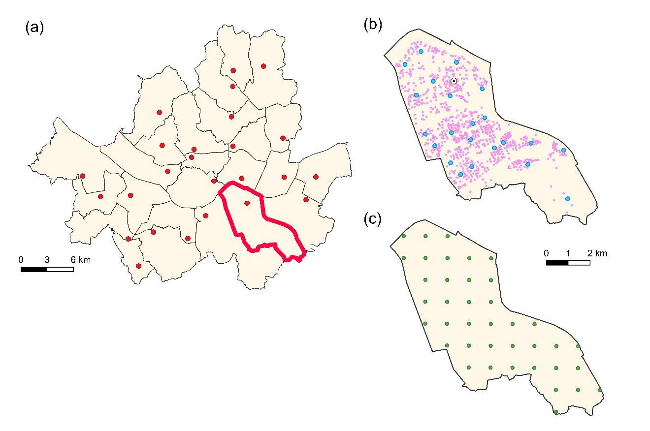

(b)

(c)

(d)

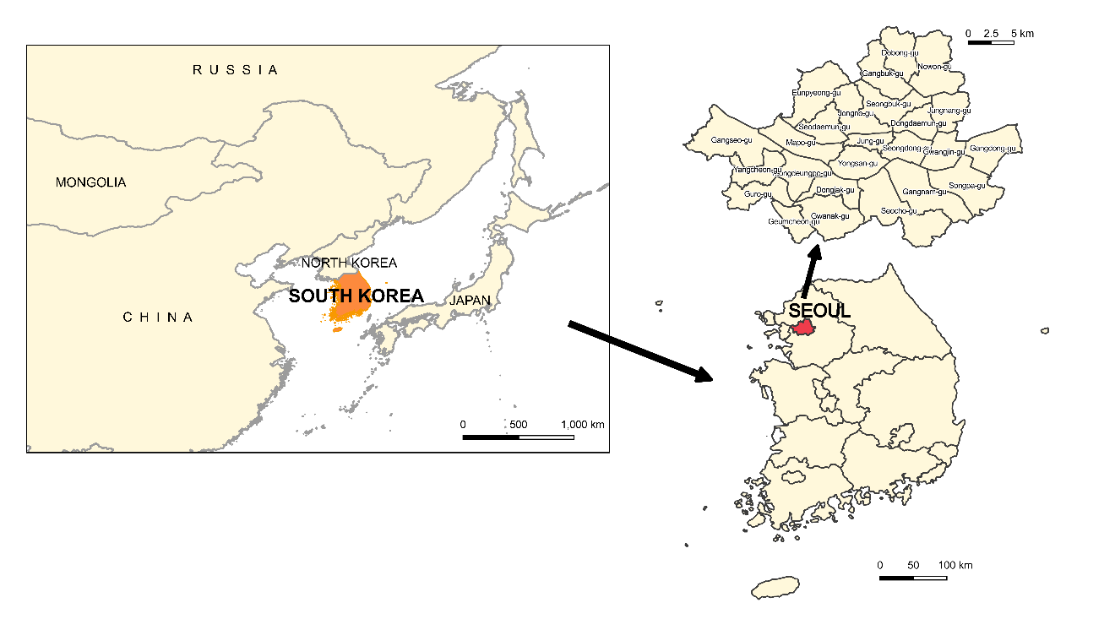

(a)

**Table S1.** Mean and standard deviation of true and predicted PM10 annual average concentrations at home addresses of 46,007 mothers under address availability, eight environmental scenarios (ES1-ES8), and exposure prediction methods in the 1st simulation.

|  |  |  |  |  |  |  |  |  |  |  |
| --- | --- | --- | --- | --- | --- | --- | --- | --- | --- | --- |
|  |  | Complete address | | | | Incomplete address | | | | |
|  | TEb | NMb | IDWAb | LURb | UKb | AAb | UKDb | UKNAb | UKCAb | UKGAb |
| ES1 | 51.16(5.56) a | 50.94(5.73) | 51.42(5.47) | 51.14(4.16) | 52.27(1.56) | 51.59(4.24) | 51.63(4.53) | 51.61(4.24) | 51.6(4.27) | 51.49(3.97) |
| ES2 | 49.80(5.97) | 49.75(5.34) | 49.83(5.20) | 49.94(3.80) | 49.97(1.59) | 49.71(4.13) | 49.91(4.80) | 49.68(4.49) | 49.81(4.38) | 49.49(4.04) |
| ES3 | 58.55(6.45) | 59.23(6.45) | 59.27(5.89) | 59.27(4.88) | 60.52(3.43) | 59.56(4.56) | 59.66(4.46) | 59.45(4.63) | 59.60(4.09) | 59.21(4.02) |
| ES4 | 46.90(5.11) | 47.68(4.59) | 47.43(3.81) | 47.48(2.71) | 47.52(1.99) | 47.61(2.56) | 47.57(2.29) | 47.42(1.21) | 47.52(1.50) | 47.25(1.04) |
| ES5 | 50.91(5.26) | 49.87(4.18) | 50.47(5.33) | 49.98(2.35) | 51.51(4.30) | 51.46(4.16) | 51.51(4.33) | 51.26(2.65) | 51.41(4.07) | 51.19(2.13) |
| ES6 | 53.05(4.66) | 53.02(4.57) | 53.22(4.68) | 52.67(2.62) | 53.21(3.45) | 53.32(4.08) | 53.37(3.54) | 53.19(2.07) | 53.22(2.86) | 52.99(2.00) |
| ES7 | 51.61(5.81) | 49.34(3.51) | 50.51(4.86) | 49.49(1.89) | 51.97(5.09) | 51.89(4.43) | 51.42(5.33) | 51.22(2.48) | 51.24(4.16) | 51.28(2.98) |
| ES8 | 51.19(5.17) | 49.66(4.00) | 50.53(4.58) | 49.53(2.03) | 51.35(4.32) | 51.97(4.29) | 51.34(4.64) | 51.21(1.74) | 51.19(3.14) | 51.13(2.41) |

a Mean (Standard deviation)

b TE: true exposure; NM: nearest-monitor; IDWA: inverse-distance-weighted-average; LUR: land use regression; UK: universal kriging; AA: area-average UKD: UK prediction at a SGG district centroid; UKNA: district average based on UK predictions at 422 neighbourhood centroids; UKCA: district average of UK predictions at 16,230 census tract centroids; UKGA: district average of UK predictions at 610 1-km grid coordinates

**Table S2.** Pearson correlation coefficients and regression coefficients between true and predicted annual-average PM10 concentrations at home addresses of 46,007 mothers in the 1st simulation

|  |  |  |  |  |  |  |  |  |  |  |  |  |  |
| --- | --- | --- | --- | --- | --- | --- | --- | --- | --- | --- | --- | --- | --- |
|  |  | ES1 |  |  | ES2 |  |  | ES3 |  |  | ES4 |  |  |
| Address | Exposure prediction d | Ra | Inter b | Slope c | R | Inter | Slope | R | Inter | Slope | R | Inter | Slope |
| Complete | NM  IDWA  LUR  UK | 0.62  0.62  0.02  0.70 | 11.69  21.01  50.28  16.78 | 0.78  0.59  0.04  0.68 | 0.49  0.50  0.03  0.47 | 19.52  27.46  47.87  22.56 | 0.61  0.45  0.04  0.55 | 0.52  0.61  0.02  0.46 | 20.83  24.77  64.50  32.29 | 0.66  0.59  -0.07  0.47 | 0.04  0.07  0.03  0.00 | 40.80  40.82  50.73  48.26 | 0.14  0.14  -0.07  -0.02 |
| Incomplete | AA  UKD  UKNA  UKCA  UKGA | 0.50  0.52  0.64  0.64  0.60 | 13.51  23.33  20.47  20.15  23.14 | 0.73  0.55  0.61  0.62  0.55 | 0.42  0.49  0.45  0.47  0.44 | 20.91  25.55  24.46  24.70  27.05 | 0.58  0.49  0.51  0.50  0.45 | 0.47  0.50  0.59  0.47  0.55 | 19.18  30.26  27.30  34.30  32.11 | 0.68  0.50  0.55  0.43  0.46 | 0.03  0.00  0.01  0.00  0.02 | 40.10  46.73  46.57  48.23  46.01 | 0.16  0.02  0.02  -0.02  0.03 |
|  |  | ES5 |  |  | ES6 |  |  | ES7 |  |  | ES8 |  |  |
| Address | Exposure prediction | R | Inter | Slope | R | Inter | Slope | R | Inter | Slope | R | Inter | Slope |
| Complete | NM  IDWA  LUR  UK | 0.30  0.21  0.36  0.37 | 22.39  39.61  26.58  25.99 | 0.55  0.20  0.49  0.50 | 0.18  0.13  0.27  0.38 | 30.84  41.87  32.96  28.44 | 0.42  0.20  0.38  0.47 | 0.13  0.14  0.65  0.67 | 34.92  43.30  15.57  12.66 | 0.30  0.12  0.71  0.75 | 0.03  0.01  0.60  0.59 | 42.52  48.08  18.11  16.05 | 0.16  0.03  0.65  0.69 |
| Incomplete | AA  UKD  UKNA  UKCA  UKGA | 0.09  0.10  0.22  0.36  0.15 | 37.86  38.95  39.23  27.73  43.12 | 0.24  0.25  0.24  0.47  0.16 | 0.04  0.08  0.19  0.26  0.16 | 43.30  40.24  42.95  36.68  43.79 | 0.18  0.25  0.19  0.31  0.17 | 0.07  0.07  0.29  0.43  0.27 | 41.07  41.41  39.42  27.09  37.59 | 0.16  0.20  0.23  0.47  0.27 | 0.00  0.01  0.17  0.40  0.14 | 49.13  47.43  44.12  31.62  42.13 | 0.01  0.09  0.14  0.38  0.18 |

a Pearson correlation coefficient between true and predicted annual-average PM10;b OLS regression intercept coefficient; c OLS regression slope coefficient

d TE: true exposure; NM: nearest-monitor; IDWA: inverse-distance-weighted-average; LUR: land use regression; UK: universal kriging; AA: area-average UKD: UK prediction at a SGG district centroid; UKNA: district average based on UK predictions at 422 neighbourhood centroids; UKCA: district average of UK predictions at 16,230 census tract centroids; UKGA: district average of UK predictions at 610 1-km grid coordinates

**Table S3.** Properties of effect estimates of true and predicted PM10 annual average concentrations on low birth weight over 1,000 simulations by address availability, ten exposure assessment methods (TE, NM, IDWA, LUR, UK, AA, UKD, UKNA, UKCA, and UKGA), and the four environmental scenarios without mean structure (ES1-ES4)

|  |  |  |  |  |  |  |  |  |  |  |  |  |  |  |  |  |  |
| --- | --- | --- | --- | --- | --- | --- | --- | --- | --- | --- | --- | --- | --- | --- | --- | --- | --- |
|  |  | ES1 |  |  |  | ES2 |  |  |  | ES3 |  |  |  | ES4 |  |  |  |
| Address | Exposure  prediction | Biasa | RMSEb | ASEc | CPd | Bias | RMSE | ASE | CP | Bias | RMSE | ASE | CP | Bias | RMSE | ASE | CP |
|  | TE | 0.01 | 1.51 | 0.77 | 0.96 | -0.04 | 1.48 | 0.78 | 0.95 | 0.03 | 1.48 | 0.75 | 0.95 | -0.02 | 1.43 | 0.74 | 0.95 |
| Complete | UK | -0.11  0.05  -0.20  -0.06 | 1.56  2.54  4.34  2.19 | 0.78  1.35  2.66  1.19 | 0.96  0.96  0.94  0.96 | -0.13  -0.03  -0.33  -0.03 | 1.54  2.50  4.51  2.41 | 0.83  1.35  2.54  1.45 | 0.93  0.95  0.96  0.94 | -0.16  -0.05  -0.09  -0.05 | 1.54  2.54  4.65  2.72 | 0.82  1.32  2.63  1.58 | 0.94  0.95  0.96  0.94 | -0.30  -0.25  -0.37  -0.30 | 1.50  2.65  4.54  3.47 | 0.76  1.36  2.65  2.05 | 0.92  0.96  0.93  0.94 |
| Incomplete | AA  UKD  UKNA  UKCA  UKGA | -0.12  -0.08  0.05  -0.03  0.08 | 1.57  2.19  2.74  2.53  3.17 | 0.82  1.17  1.48  1.40  1.77 | 0.95  0.95  0.96  0.96  0.96 | -0.15  -0.08  -0.01  0.00  0.09 | 1.55  2.42  3.27  2.84  3.83 | 0.83  1.41  1.95  1.74  2.38 | 0.94  0.94  0.94  0.94  0.94 | -0.14  -0.09  0.07  0.05  0.04 | 1.56  2.75  4.08  3.32  4.83 | 0.80  1.62  2.67  2.00  3.63 | 0.95  0.94  0.94  0.95  0.94 | -0.29  -0.19  -0.23  -0.30  -0.17 | 1.51  3.58  6.47  4.54  7.92 | 0.79  1.91  3.85  2.96  4.53 | 0.94  0.96  0.94  0.92  0.95 |

a Bias multiplied by 100

b Root mean square error multiplied by 100

c Average standard error multiplied by 100

d Coverage probability of 95% confidence interval

e TE: true exposure; NM: nearest-monitor; IDWA: inverse-distance-weighted-average; LUR: land use regression; UK: universal kriging; AA: area-average UKD: UK prediction at a SGG district centroid; UKNA: district average based on UK predictions at 422 neighbourhood centroids; UKCA: district average of UK predictions at 16,230 census tract centroids; UKGA: district average of UK predictions at 610 1-km grid centroids

**Table S4.** Properties of effect estimates of true and predicted PM10 annual average concentrations on low birth weight over 1,000 simulations by address availability ten exposure assessment methods (TE, NM, IDWA, LUR, UK, AA, UKD, UKNA, UKCA, UKGA), and the four environmental scenarios without mean structure (ES5-ES8)

|  |  |  |  |  |  |  |  |  |  |  |  |  |  |  |  |  |  |
| --- | --- | --- | --- | --- | --- | --- | --- | --- | --- | --- | --- | --- | --- | --- | --- | --- | --- |
|  |  | ES5 |  |  |  | ES6 |  |  |  | ES7 |  |  |  | ES8 |  |  |  |
| Address | Exposure prediction | Biasa | RMSEb | ASEc | CPd | Bias | RMSE | ASE | CP | Bias | RMSE | ASE | CP | Bias | RMSE | ASE | CP |
|  | TE | 0.03 | 1.50 | 0.78 | 0.95 | 0.01 | 1.49 | 0.75 | 0.95 | -0.01 | 1.40 | 0.71 | 0.95 | 0.00 | 1.40 | 0.71 | 0.95 |
| Complete | UK | -0.16  0.00  -0.03  0.01 | 1.53  3.08  2.42  2.06 | 0.77  1.65  1.31  1.10 | 0.96  0.95  0.95  0.95 | -0.20  -0.11  -0.04  -0.02 | 1.52  3.03  2.45  2.11 | 0.76  1.54  1.29  1.10 | 0.95  0.95  0.95  0.96 | -0.28  -0.23  0.01  0.00 | 1.53  3.60  1.75  1.70 | 0.80  1.90  0.94  0.89 | 0.94  0.94  0.94  0.93 | -0.29  -0.21  -0.01  -0.01 | 1.54  3.69  1.76  1.73 | 0.79  1.90  0.89  0.88 | 0.94  0.94  0.96  0.96 |
| Incomplete | AA  UKD  UKNA  UKCA  UKGA | -0.19  -0.16  0.04  0.01  0.05 | 1.76  2.02  3.10  2.33  3.71 | 0.95  1.07  1.68  1.26  2.04 | 0.95  0.94  0.94  0.94  0.95 | -0.24  -0.19  0.01  0.00  0.03 | 1.76  2.07  3.23  2.38  3.83 | 0.89  1.12  1.80  1.23  2.09 | 0.96  0.95  0.95  0.95  0.95 | -0.31  -0.24  0.08  0.02  0.01 | 2.00  1.89  3.89  2.20  3.24 | 1.03  0.99  2.07  1.19  1.70 | 0.94  0.94  0.94  0.94  0.95 | -0.25  -0.24  0.06  0.02  -0.11 | 2.04  1.93  4.07  2.23  3.31 | 1.05  1.03  2.14  1.16  1.73 | 0.95  0.95  0.94  0.96  0.95 |

a Bias multiplied by 100

b Root mean square error multiplied by 100

c Average standard error multiplied by 100

d Coverage probability of 95% confidence interval

e TE: true exposure; NM: nearest-monitor; IDWA: inverse-distance-weighted-average; LUR: land use regression; UK: universal kriging; AA: area-average UKD: UK prediction at a SGG district centroid; UKNA: district average based on UK predictions at 422 neighbourhood centroids; UKCA: district average of UK predictions at 16,230 census tract centroids; UKGA: district average of UK predictions at 610 1-km grid centroids